■Revision History
Rev. | Change | Date
00 | Initial Version | 2007.06.13

■ Optical Specification
NO | PARAMETER |  | SYMBOL | SPECIFICATION | UNIT
1 | Optic Fiber |  | - | Single Mode Fiber 9/125um | -
2 | Optical Power Level |  | - | 2 ~ 6 | mW
3 | Wavelength | 1310nm | Master | 1310±10nm | nm
 |  | 1550nm | Slave | 1550±10nm
4 | Bandwidth |  | Modem  (RS-232C) | Master: TX 29.9 / RX 26.9  Slave: TX 26.9 / RX 29.9 | MHz
5 | Optic connector |  | - | SC/APC | -
6 | Modulation Gain |  | - | 0.1 ~ 0.15 | mW/mA
7 | Optical Alarm |  | LD | Below -5 dBm | dBm
 |  |  | PD | Below -15 dBm

■ Electrical Specification
NO | PARAMETER | SYMBOL | FREQUENCY | SPECIFICATION | UNIT
1 | RF Gain(RF Loss) | - | 950~2150 MHz | 0 ± 3 | dB
2 | RF VSWR | S11,S22 |  | 1.5:1 | -
3 | 0IP3( 0dBm / 2 tone) | - |  | 25 min. | dBm
4 | Noise Floor | - |  | -133 | dBm/Hz
5 | RF Isolation | - |  | -60 | dB
6 | Flatness | - |  | ±2 | dB
7 | Input Power | - | - | -10 Max. | dBm
8 | Power | - | - | 110/220 VAC(+12V) | -
9 | DC and Alarm | - | - | LED Display | -
10 | RF Connector | - | - | SMA(F) – RF IN, OUT | -
11 | Mechanical Size | - | - | See the Dimension | -

■ Dimension
<Master>
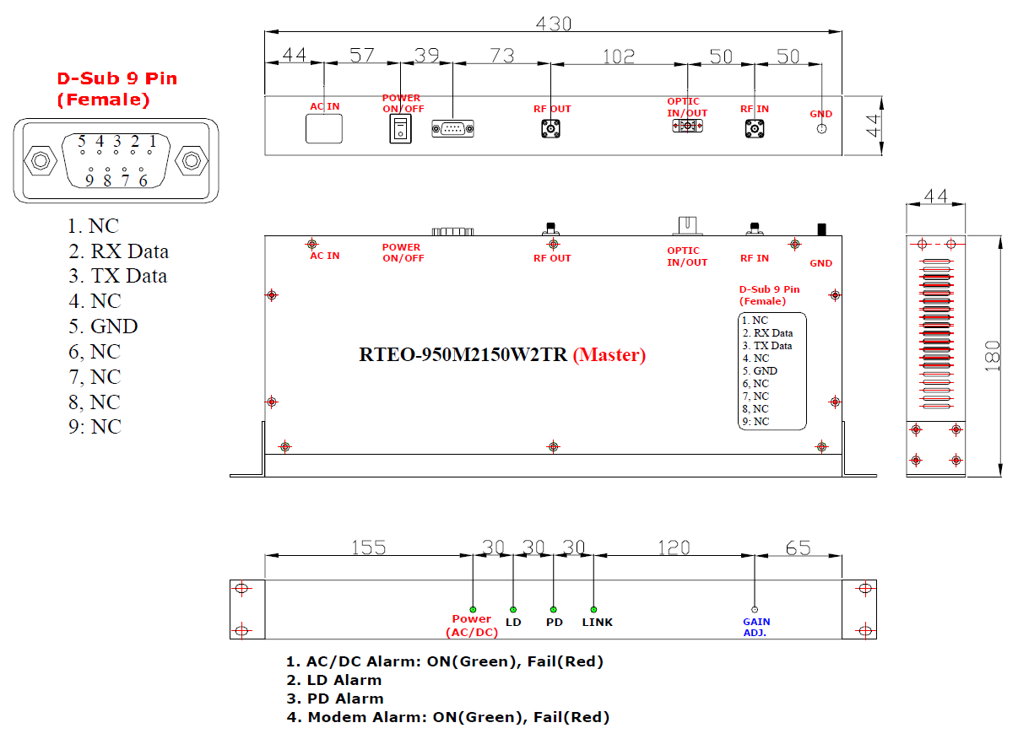

<Slave>
